 

|  |  |
| --- | --- |
|  |  |

Data Compliance Test (DCT)

Test Cases for

Referral Record

*<HCP Name>*

Table of Contents

1. Testing Instructions to HCPs 3

1.1 Self-Service Testing Phase 3

1.2 Final Testing Phase 3

1.3 Preparation DCT Test Report 4

2. Test Case Details 5

REF-LV1-001 [FOR LEVEL 1 DATA UPLOAD ONLY] 5

REF-LV1-002 [FOR LEVEL 1 DATA UPLOAD ONLY] 9

3. Appendix – Sample Messages 14

4. Appendix – Testing HCP and HCRs Information 15

5. Appendix – Sample Results in eHR Viewer (EVE) 15

6. Appendix – Actual Data Values (Sample) 18

# Testing Instructions to HCPs

## Self-Service Testing Phase

* After development of the data upload programmes, you can use the **Self-Service test accounts and test HCRs** provided by eHealth for connection to the eHealth testing environment and proceed with the self-service testing.
* You can proceed with the Self-service test at your own pace by following this Self-Service Testing Guide and using the test cases provided in section 2.
* You can verify the **correctness** and **completeness** of the data upload by:
  + checking the interface files / messages generated in your system against the sample expected results of interface files /messages for all test cases as provided;
  + checking the results on eHR Viewer (EVE) by logging into the testing eHealth with the provided test account; and
  + checking the upload status through Process Summary and Exception Report in eHR Inbox by logging into the testing eHealth.
* For data fields requiring eHR Codex values, you can refer the Code Sets provided with the Self-Service Kit.
* For details of technical requirements of the data interface files, please refer to the ‘Developer Quick Guide for Referral Records Upload to eHealth.docx’.
* You are required to perform the test cases that are relevant to the data compliance level (Level 1) supported by your clinic.
* You are required to perform the first batch of data upload by **Data Materialization** (**DM**) mode. **DM mode** is denoted in the interface by a fixed value **BL-M** in *HL7 OBX.4*
* You should use **Incremental Load** (**INC**) mode for the second batch of data upload to update the previously uploaded records. **INC mode** is denoted in the interface by a fixed value **BL** in *HL7 OBX.4.*
* Since the **DM** mode would replace the corresponding records previously uploaded to eHealth, you may repeat your testing unlimited number of times by uploading the first batch by **DM** mode.
* It should be noted that the data field “Record Key” should be unique for each referral record.
* When all required test cases can be completed smoothly and correctly in this phase, you can proceed to the Final Testing Phase and submit **production environment setup form** to eHR DCT Support for preparation.

## Final Testing Phase

* You can start the Final Testing Phase once all test cases in the Self-Service Testing phase are passed.
* You should start Final Test by executing the test cases provided in section 2 with **Final Testing HCRs** provided by eHR DCT Support.
* You can verify the **correctness** and **completeness** of testing results by checking results in eHR Viewer (EVE) and the upload status through Process Summary and Exception Report in eHR Inbox.
* For Referral Record DCT test cases, there are **TWO** batches of data files / transactions to be uploaded to the testing eHealth. The required records must be correctly uploaded from these 2 consecutive batches respectively.
* The Final Test will be considered PASSED if all the following criteria are met:
  + The TWO batches of test data files are uploaded consecutively in the correct sequence. The second batch of data files/transactions must be submitted after completion of processing of the first batch by eHealth.
  + No additional data files / transactions are uploaded in between or after the uploads of the above two batches of data files / transactions to amend any records.
  + No exception records are reported from the uploads.
  + No manual interventions have been made to the data files / transactions.
* If the Final Test failed, you can re-attempt the Self-Service Test and Final Test until a successful run can be completed.

## Preparation DCT Test Report

* Once you have successfully passed the Final Test based on the above criteria, you should complete this document by attaching the below items to this document at the appropriate space provided:
  + Actual data files uploaded
  + Screen-shot of each test case
* You are required to submit this completed ‘DCT Test Cases’ document to eHR DCT Support for further processing. eHR DCT Support will provide feedback **within 10 working days**.

# Test Case Details

* *REF-LV1-001 and REF-LV1-002 : Only applicable for testing level 1 data upload*
* *Please complete and collect the upload results for REF-xxx-001 before proceeding to REF-xxx-002.*

| **1** | **Test Case ID** | REF-LV1-001 [FOR LEVEL 1 DATA UPLOAD ONLY] | |
| --- | --- | --- | --- |
|  | **Function Description** | HCP has received the sharing consents from testing HCRs, then perform first data upload of HCRs’ clinical records to eHealth by DM Mode for level 1 data. | |
| **Subsequent case of** | N/A | |
| **Testing Assumption** | * HCR1-HCR3 have already given sharing to sharing consents to the HCP. * The EMR system (EMRS) will upload Batch 1 data files to eHealth with all referral records of <HCR1> - <HCR3> created by DM mode. | |
| **Test Actions** | HCP creates below referral records in EMR system: | |
| 1a | **Case scenario:** Input new referral record in the EMRS for <HCR1> for PDF report generation as follows:   * Referral date = 10-Jan-2024 10:00:00 * Type of referral document local description = Request referral * Referral document issuance – HCP local name = [source system provided] * Referral document recipient - HCP local name = “HA” * Referral document recipient - HCI local name = “QEH”   == Actual data values (Refer to “Appendix - Actual Data Values (Sample)” for details)  Expected data contents for Level 1 interface record:   * Referral date = 10-Jan-2024 10:00:00 * Type of referral document code= Request * Type of referral document description = Request referral * Type of referral document local description = Request referral * Referral number = [source system provided] * Referral document issuance – HCP identifier = [source system provided] * Referral document issuance – HCP long name = [source system provided] * Referral document issuance – HCP local name = [source system provided] * Referral document recipient - HCP local name = “HA” * Referral document recipient - HCI local name = “QEH” * Referral Report Title = “Referral letter” * Referral Report (Text) = null * File indicator = 1 * File name of Referral report = [follow naming standards as specified in General Guide] * Referral Report (PDF) = Generated PDF report with the above data and file name |
| 1b | **Case scenario:** Input new referral record in the EMRS for <HCR2> for PDF report generation as follows:   * Referral date = 15-Jan-2024 10:00:00 * Type of referral document local description = Reply referral * Referral document issuance – HCP local name = [source system provided] * Referral document recipient - HCP local name = “Department of Health” * Referral document recipient - HCI local name = “Kowloon Families Clinic”   == Actual data values (Refer to “Appendix - Actual Data Values (Sample)” for details)  Expected data contents for Level 1 interface record:   * Referral date = 15-Jan-2024 10:00:00 * Type of referral document code= Reply * Type of referral document description = Reply referral * Type of referral document local description = Reply referral * Referral number = [source system provided] * Referral document issuance – HCP identifier = [source system provided] * Referral document issuance – HCP long name = [source system provided] * Referral document issuance – HCP local name = [source system provided] * Referral document recipient - HCP local name = “Department of Health” * Referral document recipient - HCI local name = “Kowloon Families Clinic” * Referral Report Title = “Referral letter” * Referral Report (Text) = null * File indicator = 1 * File name of Referral report = [follow naming standards as specified in General Guide] * Referral Report (PDF) = Generated PDF report with the above data and file name |
| 1c | **Case scenario:** *(Only applicable for Level 1 data upload without PDF report)*  Input new referral record in the EMRS for <HCR3> for text report generation as follows:   * Referral date = 20-Jan-2024 10:00:00 * Type of referral document local description = Request referral * Referral document issuance – HCP local name = [source system provided] * Referral document recipient - HCP local name = “HA” * Referral document recipient - HCI local name = “HA Hospital”   == Actual data values (Refer to “Appendix - Actual Data Values (Sample)” for details)  Expected data contents for Level 1 interface record:   * Referral date = 20-Jan-2024 10:00:00 * Type of referral document code= Request * Type of referral document description = Request referral * Type of referral document local description = Request referral * Referral number = [source system provided] * Referral document issuance – HCP identifier = [source system provided] * Referral document issuance – HCP long name = [source system provided] * Referral document issuance – HCP local name = [source system provided] * Referral document recipient - HCP local name = “HA” * Referral document recipient - HCI local name = “HA Hospital” * Referral Report Title = “Referral letter” * Referral Report (Text) = <Text report with the above data> * File indicator = 0 * File name of Referral report = null * No PDF report generated |
|  | **Expected eMR System Behavior** | 1. HCP’s EMR system will upload **Batch 1** data for insertion of the following referral records by **DM mode**:  * **Level 1:** data from test cases **1a-1c**.  1. **Batch 1** data files should include below files: <samples> 2. Participant List (PL) 3. Data File (DF) 4. HL7 message with signature 5. Zip File (embedded PL, DF and HL7 message files) 6. Zip Control File (contains the filenames of PL, DF and HL7 message) 7. EMR system uploads **Batch 1** data files (‘Zip File’ and ‘Zip Control File') to eHealth. 8. HCP verifies the data upload status by reviewing the 'Process Summary Report' and 'Exception Report' in eHR Inbox. 9. HCP verifies the completeness and correctness of data uploaded in eHR Viewer. | |
|  | **Results Verification** | * HCP verifies the interface file contents and check if the uploaded records can be properly viewed in eHR Viewer (EVE). HCP must also reviews if the data batches uploaded can be processed successfully or rejected through 'Process Summary Report' and 'Exception Report' in eHR Inbox. | |
| **Actual Result**  **(Screenshot / Attachment)** | **Data Files Uploaded:**  *<Attached the Zip file and Control file; password to unzip the file>* | |
| **Attachment/Screenshot:**  *<Attached the screen shots of records uploaded in eHR Viewers>* | |
| **Remark** | *<State your reasons/ justification for exemption with case number>* | |
| **Testing Date** | *<Provided by HCP>* | |
| **Verified By** | *<Provided by HCP>* | |

| **2** | **Test Case ID** | REF-LV1-002 [FOR LEVEL 1 DATA UPLOAD ONLY] | |
| --- | --- | --- | --- |
|  | **Function Description** | There are subsequent changes in HCRs’ referral records uploaded in Batch 1. HCP uploads incremental changes to eHealth by INC Mode for Level 1 data. | |
| **Subsequent case of** | REF-LV1-001 | |
| **Testing Assumption** | HCP has already verified that Batch 1 data have been processed successfully with correct test results. | |
| **Test Actions** | HCP updates referral records from Batch 1 in EMR system (EMRS) as follows: | |
| 2a | **Case scenario:** Input new referral record in the EMRS for <HCR1> for PDF report generation as follows:   * Referral date = 13-Jan-2024 15:00:00 * Type of referral document local description = Reply referral * Referral document issuance – HCP local name = [source system provided] * Referral document recipient - HCP local name = “HA” * Referral document recipient - HCI local name = “PWH”   == Actual data values (Refer to “Appendix - Actual Data Values (Sample)” for details)  Expected data contents for Level 1 interface record:   * Referral date = 13-Jan-2024 15:00:00 * Type of referral document code= Reply * Type of referral document description = Reply referral * Type of referral document local description = Reply referral * Referral number = [source system provided] * Referral document issuance – HCP identifier = [source system provided] * Referral document issuance – HCP long name = [source system provided] * Referral document issuance – HCP local name = [source system provided] * Referral document recipient - HCP local name = “HA” * Referral document recipient - HCI local name = “PWH” * Referral Report Title = “Referral letter” * Referral Report (Text) = null * File indicator = 1 * File name of Referral report = [follow naming standards as specified in General Guide] * Referral Report (PDF) = Generated PDF report with the above data and file name |
| 2b | **Case scenario:** *(Only applicable for Level 1 data upload without PDF report)*  Input new referral record in the EMRS for <HCR1> for text report generation as follows:   * Referral date = 20-Feb-2024 10:00:00 * Type of referral document local description = Request referral * Referral document issuance – HCP local name = [source system provided] * Referral document recipient - HCP local name = “HA” * Referral document recipient - HCI local name = “PWH”   == Actual data values (Refer to “Appendix - Actual Data Values (Sample)” for details)  Expected data contents for Level 1 interface record:   * Referral date = 20-Feb-2024 10:00:00 * Type of referral document code= Request * Type of referral document description = Request referral * Type of referral document local description = Request referral * Referral number = [source system provided] * Referral document issuance – HCP identifier = [source system provided] * Referral document issuance – HCP long name = [source system provided] * Referral document issuance – HCP local name = [source system provided] * Referral document recipient - HCP local name = “HA” * Referral document recipient - HCI local name = “PWH” * Referral Report Title = “Referral letter” * Referral Report (Text) = <Text report with the above data> * File indicator = 0 * File name of Referral report = null * No PDF report generated |
| 2c | **Case scenario:** Update [Referral date], [Referral number] and [Referral remark] of the referral records input for test case 1(a) for <HCR1> in the EMRS as follows:   * Referral date = 11-Jan-2024 14:30:00 * Referral number = [Change to another number] * Referral remark = “Please bring the letter for booking”   == Actual data values (Refer to “Appendix - Actual Data Values (Sample)” for details)  Expected data contents for Level 1 interface record:   * Referral date = 11-Jan-2024 14:30:00 * Type of referral document code= Request * Type of referral document description = Request referral * Type of referral document local description = Request referral * Referral number = [Changed number - source system provided] * Referral document issuance – HCP identifier = [source system provided] * Referral document issuance – HCP long name = [source system provided] * Referral document issuance – HCP local name = [source system provided] * Referral document recipient - HCP local name = “HA” * Referral document recipient - HCI local name = “HA Hospital” * Referral remark = “Please bring the letter for booking” * Referral Report Title = “Referral letter” * Referral Report (Text) = null * File indicator = 1 * File name of Referral report = [follow naming standards as specified in General Guide] * Referral Report (PDF) = Generated PDF report with the above data and file name |
| 2d | **Case scenario:** Update [Referral date], [Referral number] and [Referral remark] of the referral records input for test case 1(c) for <HCR3> in the EMRS as follows:   * Referral date = 21-Jan-2024 14:30:00 * Referral number = [Change to another number] * Referral remark = “Please bring the letter for booking”   == Actual data values (Refer to “Appendix - Actual Data Values (Sample)” for details)  Expected data contents for Level 1 interface record:   * Referral date = 21-Jan-2024 14:30:00 * Type of referral document code= Request * Type of referral document description = Request referral * Type of referral document local description = Request referral * Referral number = [Changed number - source system provided] * Referral document issuance – HCP identifier = [source system provided] * Referral document issuance – HCP long name = [source system provided] * Referral document issuance – HCP local name = [source system provided] * Referral document recipient - HCP local name = “HA” * Referral document recipient - HCI local name = “HA Hospital” * Referral remark = “Please bring the letter for booking” * Referral Report Title = “Referral letter” * Referral Report (Text) = <Text report with the above data> * File indicator = 0 * File name of Referral report =null * No PDF report generated |
| 2e | **Case scenario:** Delete referral record of 1(b) for <HCR2> in the EMRS  == Actual data values (Refer to “Appendix - Actual Data Values (Sample)” for details)  Expected data contents for Level 1 interface record:   * Batch 2 Data file will contain 1 Delete transaction for record 1(b) |
|  | **Expected eMR System Behavior** | 1. HCP’s EMR system will upload **Batch 2** data file with the following by **INC mode**:  * **Level 1:** data from test cases **2a-2e**.  1. **Batch 2** data files should include below files: <samples>    1. Participant List (PL)    2. Data File (DF)    3. HL7 message with signature    4. Zip File (embedded PL, DF and HL7 message files)    5. Zip Control File (contains the filenames of PL, DF and HL7 message) 2. EMR system uploads **Batch 2** data files (‘Zip File’ and ‘Zip Control File') to eHealth. 3. HCP verifies the data upload status by reviewing the 'Process Summary Report' and 'Exception Report' in eHR Inbox. 4. HCP verifies the completeness and correctness of data uploaded in eHR Viewer. | |
|  | **Results Verification** | * HCP verifies the interface file contents and check if the uploaded records can be properly viewed in eHR Viewer (EVE). HCP must also reviews if the data batches uploaded can be processed successfully or rejected through 'Process Summary Report' and 'Exception Report' n eHR Inbox. | |
| **Actual Result**  **(Screenshot / Attachment)** | **Data Files Uploaded:**  *<Attached the Zip file and Control file; password to unzip the file>* | |
| **Attachment/Screenshot:**  *<Attached the screen shots of records uploaded in eHR Viewers>* | |
| **Remark** | *<State your reasons/ justification for exemption with case number>* | |
| **Testing Date** | *<Provided by HCP>* | |
| **Verified By** | *<Provided by HCP>* | |

# Appendix – Sample Messages

|  |  |  |  |  |
| --- | --- | --- | --- | --- |
| **Test Case ID** | **Step No.** | **File Type** | **Bulk Load Format** | **SOAP Format**  **(by LAAM)** |
| REF-LV1-001 | [DM]  1a-1c | Participant List (PL) |  |  |
| Data File (DF) |  |
| HL7 Message |  |
| Zip File | *(Password: Abcd1234)* |
| Control File |  |
| REF-LV1-002 | [INC]  2a-2e | Participant List (PL) |  |  |
| Data File (DF) |  |
| HL7 Message |  |
| Zip File | *(Password: Abcd1234)* |
| Control File |  |

# Appendix – Testing HCP and HCRs Information

|  |  |
| --- | --- |
| **Sample Message** |  |
| **Self-Service Testing** | *<Attach the testing HCRs excel file used>* |
| **Final Testing** | *<Attach the testing HCRs excel file used>* |

* + eHR DCT Support will provide other sets of testing HCRs for HCP to perform Self-Service testing and Final testing respectively.

# Appendix – Sample Results in eHR Viewer (EVE)

* After logging on the eHealth portal and searching the HCR, click **Tree node** of Referral to Document View in Home Page.

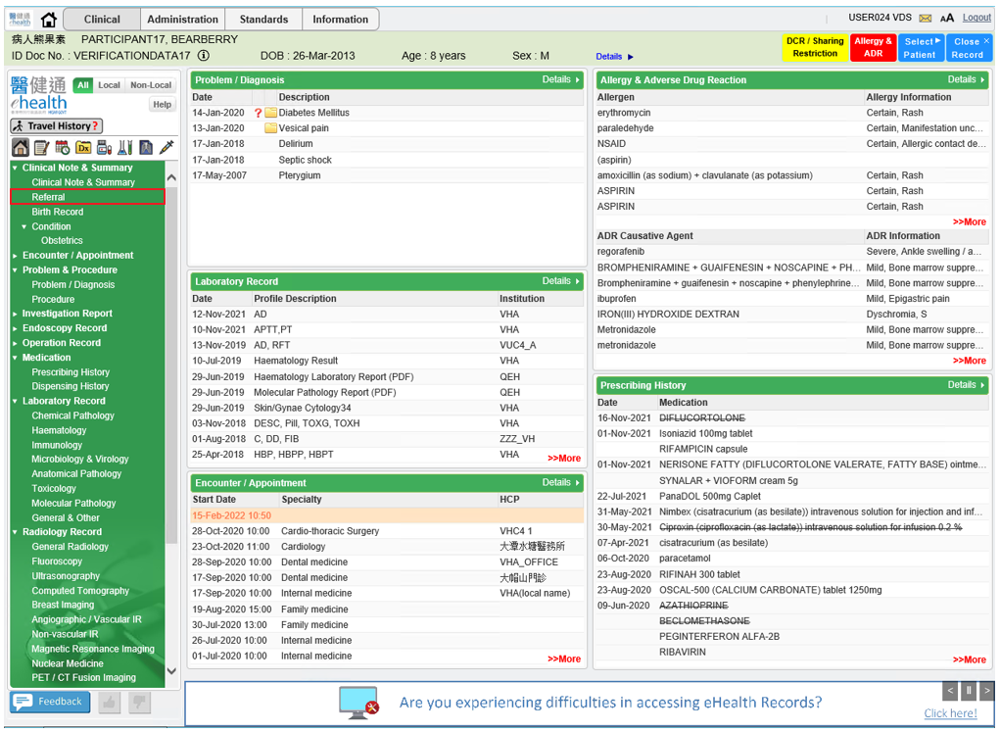

* In Referral Document View, it shows all Referral record

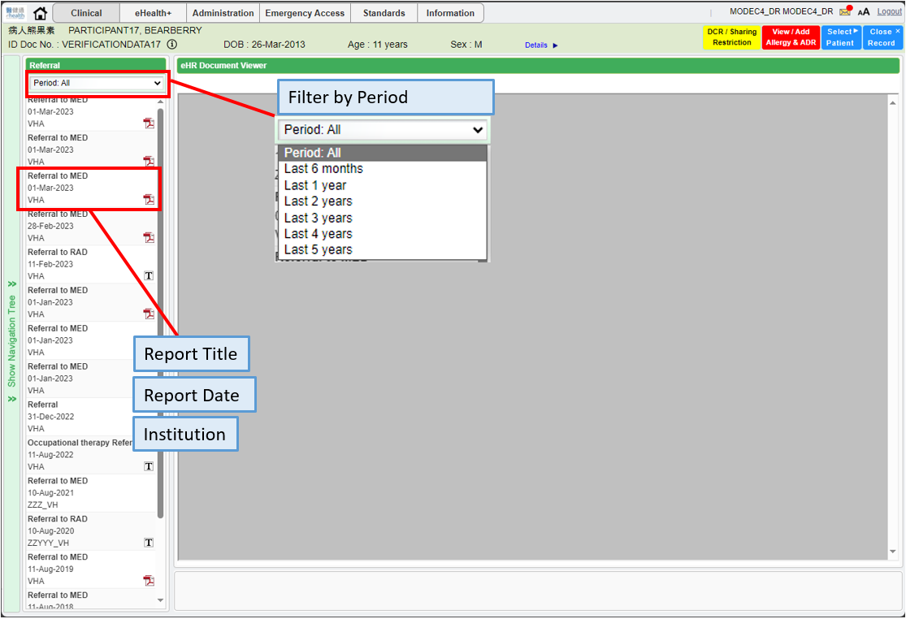

* Click PDF icon to show the report. Referral Remark shows on the bottom of Document View.

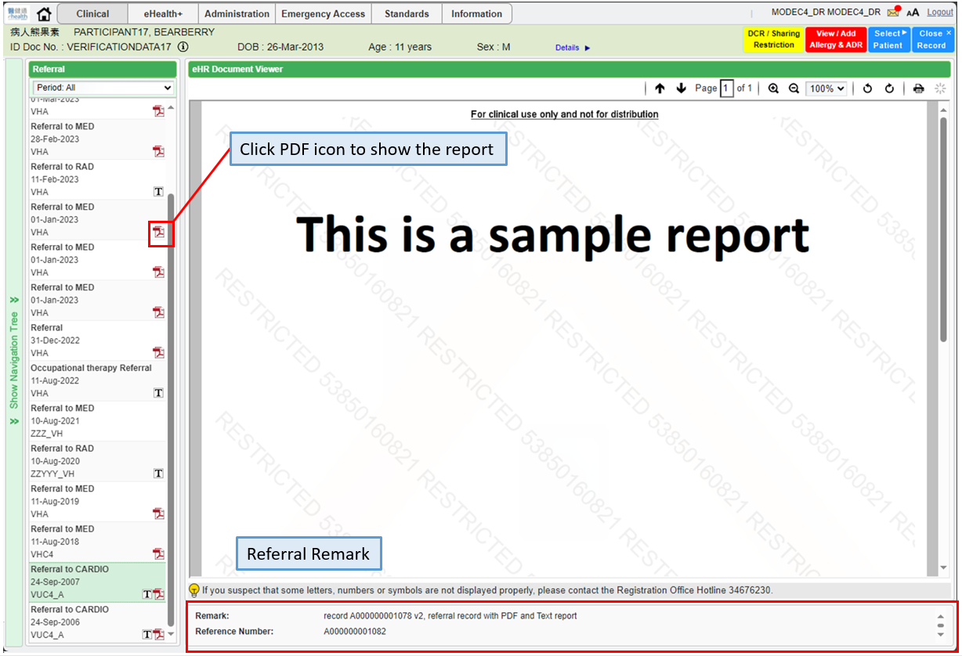

* 1. Click TEXT icon to show the report.

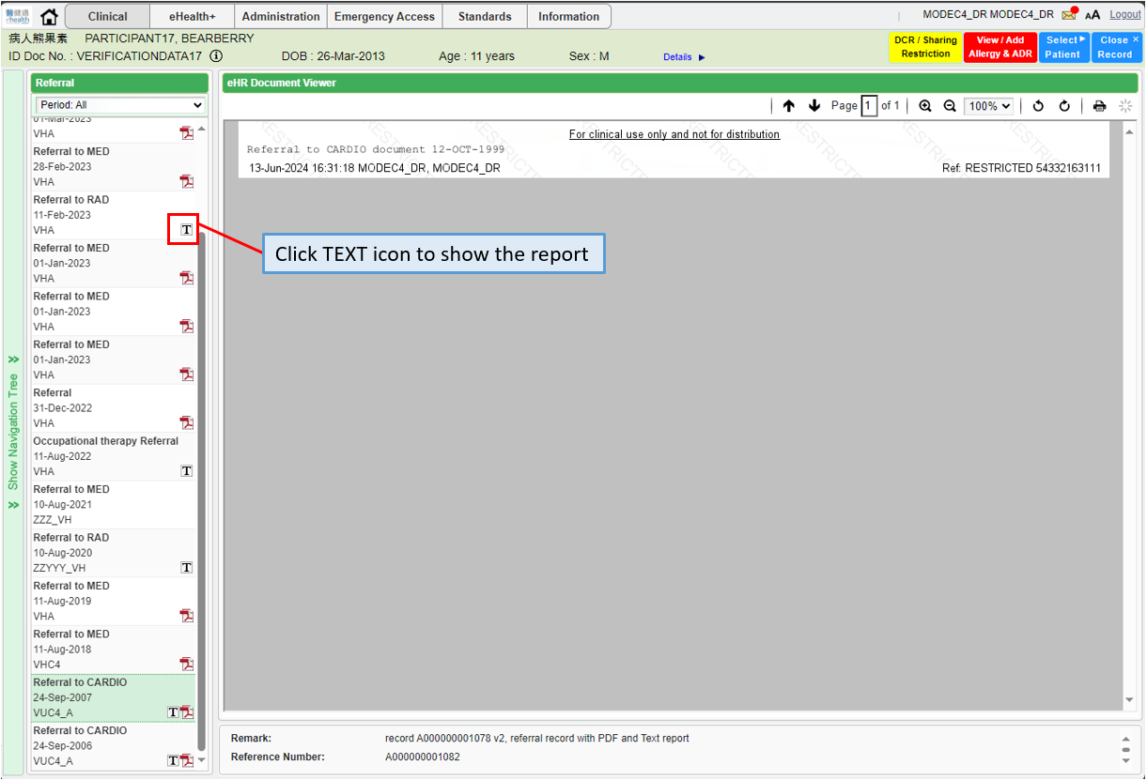

# Appendix – Actual Data Values (Sample)

If the actual values entered are various from the test case, please provide actual values as below.

If the value is not inputted, please use [BLANK] to indicate that empty value is inputted intentionally.

